# **Ultrasonic Sensor and the project on this sensor**

**By Shikhar Gupta**

* **Introduction**

An ultrasonic sensor is an electronic device that measures the distance of a target object by emitting ultrasonic sound waves, and converts the reflected sound into an electrical signal. Ultrasonic waves travel faster than the speed of audible sound (i.e. the sound that humans can hear).

* **How Ultrasonic sensor works?**
* Ultrasonic sensors have two main components: the transmitter (which emits the sound using piezoelectric crystals) and the receiver (which encounters the sound after it has travelled to and from the target).
* In order to calculate the distance between the sensor and the object, the sensor

Measures the time it takes between the emissions of the sound by the transmitter to its contact with the receiver. The formula for this calculation is [**D = ½ T x C**](https://www.arrow.com/en/research-and-events/articles/ultrasonic-sensors-how-they-work-and-how-to-use-them-with-arduino) (where D is the distance, T is the time, and C is the speed of sound ~ 343 meters/second).

* For example, if a scientist set up an ultrasonic sensor aimed at a box and it took 0.025 seconds for the sound to bounce back, the distance between the ultrasonic sensor and the box would be:

|  |
| --- |
| * **D = 0.5 x 0.025 x 343** |

Or about 4.2875 meters.

* + 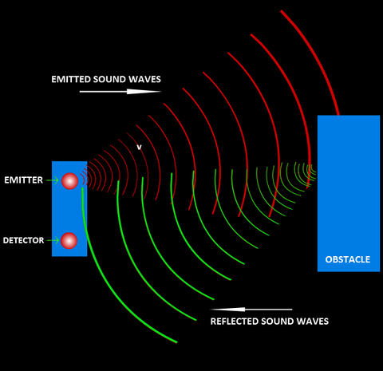
* **Uses**

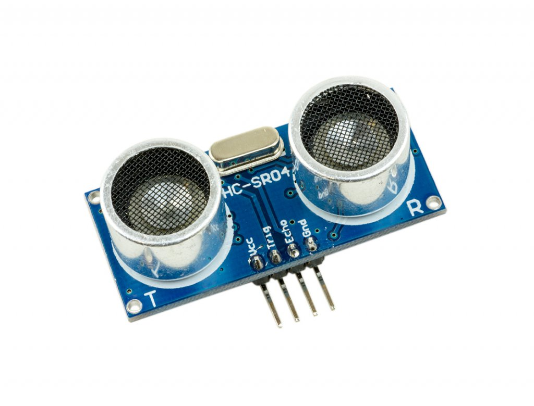

* Ultrasonic sensors are used primarily as [**proximity sensors**](https://www.fierceelectronics.com/sensors/what-a-proximity-sensor). They can be found in automobile self-parking technology and anti-collision safety systems. Ultrasonic sensors are also used in robotic obstacle detection systems, as well as manufacturing technology. [**In comparison to infrared (IR) sensors**](https://www.maxbotix.com/articles/ultrasonic-or-infrared-sensors.htm) in proximity sensing applications, ultrasonic sensors are not as susceptible to interference of smoke, gas, and other airborne particles (though the physical components are still affected by variables such as heat).
* Ultrasonic sensors are also used as [**level sensors**](https://www.fierceelectronics.com/sensors/what-a-level-sensor) to detect, monitor, and regulate liquid levels in closed containers (such as vats in chemical factories). Most notably, ultrasonic technology has enabled the medical industry to produce images of internal organs, identify tumours, and ensure the health of babies in the womb.

**Mini project on Radar system using ultrasonic sensor, servo motor, Arduino board using Arduino IDE and Processing IDE.**

**Objective:-**

To construct the radar system using ultrasonic sensor. Radar is a long-range object detection system that uses radio waves to establish certain parameters of an object like its range, speed and position. Radar technology is used in aircrafts, missiles, marine, weather predictions and automobiles.

All you need for this [Arduino Project](https://howtomechatronics.com/arduino-projects/) is an Ultrasonic Sensor for detecting the objects, a small hobbyist Servo Motor for rotating the sensor and an Arduino Board for controlling them.

**Hardware and applications required or used:**

#### Hardware

* Arduino MEGA
* HC-SR04 Ultrasonic Sensor
* TowerPro SG90 Servo Motor
* Connecting Wires
* Jumper Cables
* 5V Power Supply
* USB Cable (for Arduino)

#### Software

* Arduino IDE
* Processing Application

### **Circuit Design:-**

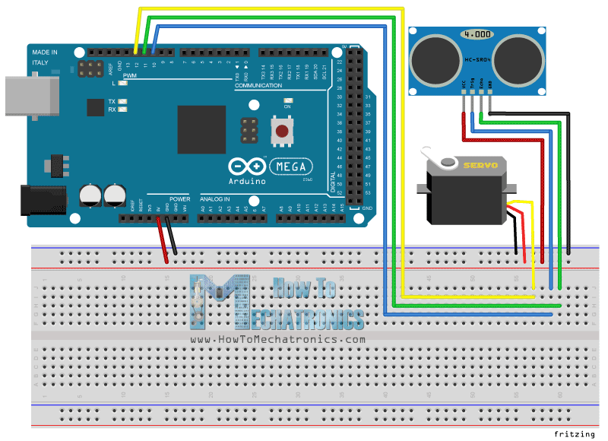

**Procedure:-**

* If you look at the circuit diagram, the design of the circuit for this project is very simple. The control pin of the servo is connected to Pin 11 of the Arduino while the TRIG and ECHO Pins of the Ultrasonic Sensor are connected to Pins 9 & 10 of Arduino respectively.
* A separate 5V power supply (with common GND) is given to the Servo Motor and the Ultrasonic Sensor.
* After making the connections, there is one important step in the construction you need to perform (not mandatory). Since the Ultrasonic Sensor must sweep an arc of 1800 (with the help of the Servo) which can be used by folding cardboard.
* Processing is a visual arts based software for learning to code. The next step is to download a special library called “Toxi”.
* Paste the code given in github.

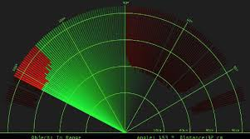

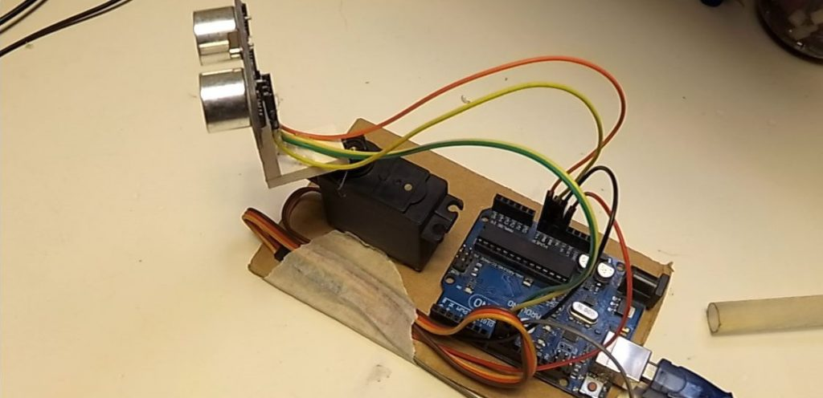

**Result:-**

Thus the project is created to show the working of ultrasonic sensor using Arduino IDE and Processing app.